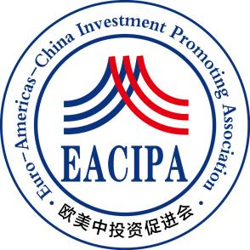

**Euro-Americas-China Investment Promoting Association**

**Donation Information Form for Chinese Returned Entrepreneurship Fund**

Article 1 The main objective of this public welfare fund is to provide financial support for Chinese young people to further their studies in overseas universities and colleges, as well as to start their own businesses and find employment, so as to help Chinese outstanding talents to expand their international horizons and to accumulate international learning and working experience.

Article 2 The Public Welfare Fund does not charge an administrative fee, and the donated funds will be disbursed in full to the recipients of the donations.

Article 3 The public welfare fund does not open online payment channels, after receiving the donation application, the staff of the European-American China Investment Promotion Association will contact you within one week and inform you of the specific donations.

Article 4 Please fill in the donation application form carefully and send it to the email address：**stanly.shen@eacipa.org**。

Article 5 After the success of the donation, the donation funds will not support the return.

Article 6 If the donation amount is more than RMB 10,000, EMECIPA will issue a donation certificate for you.

Article 7 The right of interpretation of these measures shall be vested in the Investment Promotion Council of Europe and the United States.

|  |  |  |  |  |  |
| --- | --- | --- | --- | --- | --- |
| **Name** |  | **Gender** |  | **Age** |  |
| **Nationality** |  | **Current residence** |  | | |
| **Phone** |  | **Mailbox** |  | | |
| **Currency** |  | **Proposed donation amount** |  | | |
| **What you want to say** |  | | | | |