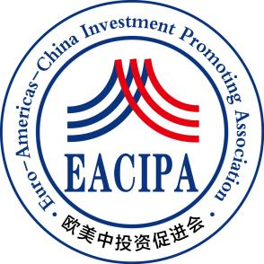

**Euro-Americas-China Investment Promoting Association**

**International Education and Career Development Fund Application Form**

**Application qualifications**

Article 1 Nationality of the People's Republic of China.

Article 2: Overseas personnel pursuing undergraduate or higher degrees.

Article 3: Graduates from domestic and foreign universities who have worked or started businesses overseas within 3 years.

Article 4: The age at the time of application shall not exceed 40 years old; Postdoctoral researchers should not be over 45 years old when registering.

Article 5: Each applicant can only apply once in the same year.

Article 6: Applicants who have received or are currently receiving funding from other national study abroad funds or entrepreneurship funds shall not be accepted.

Article 7: The application amount for public welfare funds varies from $6000 to $10000 per person, depending on the location, school, and degree of study.

Article 8: This public welfare fund has not opened an online payment channel. Please fill out the application form carefully and send the application form and related materials to the email address:**stanly.shen@eacipa.org**.After receiving the application and passing the review, the staff of the European China Investment Promotion Association will contact you within one week and inform you of the specific application matters.

Article 9: The power of interpretation of these measures belongs to the European and American China Investment Promotion Association.

|  |  |  |  |  |  |  |  |
| --- | --- | --- | --- | --- | --- | --- | --- |
| **Personal Information** | **Name** |  | **Gender** |  | **Nationality/Place of Origin** |  | **photo** |
| **Foreign language proficiency** |  | **Date of Birth** |  | **Marital status** |  |
| **Education level** |  | **ID No** |  | | | |
| **Enrollment or**  **Graduation institution** |  | | | | | |
| **Fax** |  | | | **E-mail** |  | |
| **Address** |  | | | **Phone** |  | |
| **Personal Academic Resume** |  | | | | | | |
| **Career and Entrepreneurship Resume** |  | | | | | | |
| **Introduction to Academic Mentors** |  | | | | | | |
| **Future development plan** |  | | | | | | |

Note: Materials need to be uploaded

1. Scanned copies of the front and back of the ID card

2. Admission Notice, Graduation Certificate or Student Registration Certificate

3 Foreign Language Proficiency Transcript

4. Academic achievements, scientific research achievements, patents and other supporting documents

5 Mentor recommendation letters

Please send the above materials along with the application form to the email address **stanly.shen@eacipa.org**