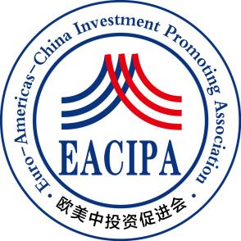

**Euro-Americas-China Investment Promoting Association**

**International Education and Career Development Fund Donation Information Form**

The main objective of this public welfare fund is to provide funding for Chinese youth to pursue further education, entrepreneurship, and employment in overseas universities, and to assist outstanding Chinese talents in expanding their international horizons and accumulating international learning and work experience.

Article 2: This public welfare fund does not charge management fees, and the donated funds will be fully distributed to the recipient.

Article 3: This public welfare fund has not opened an online payment channel. After receiving the donation application, the staff of the European and American China Investment Promotion Association will contact you within one week and inform you of the specific donation matters.

Article 4: After successful donation, the donated funds will not be refunded.

Article 5: If the donation amount is more than 10000 yuan, the European and American China Investment Promotion Association will issue a donation certificate to you.

Article 6: Please fill out the donation application form carefully and send it to the email address:**stanly.shen@eacipa.org.**

Article 7: The power of interpretation of these measures belongs to the European and American China Investment Promotion Association.

|  |  |  |  |  |  |
| --- | --- | --- | --- | --- | --- |
| **Name** |  | **Gender** |  | **Age** |  |
| **Nationality** |  | **Current residence** |  | | |
| **Phone** |  | **Mailbox** |  | | |
| **Currency** |  | **Proposed donation amount** |  | | |
| **What you want to say** |  | | | | |